Identifying the real problem

“In this matter of causality, it is a great inconvenience that the real world is given to us once only. We cannot know what would have happened if something had been different. We cannot repeat an experiment changing just one variable; the hands of the clock will have moved, and the moons of Jupiter.” John Bell [Bell]

I’ve been compiling the data for Figure 1 for a couple of years now, occasionally adding new data as it is published. It is getting harder to read as curves are crossing each other but the qualitative interpretation should be pretty clear. We are killing the biosphere, destroying the habitability of the planet and causing the sixth extinction event. I submit that this is the real problem, not climate change. Human-caused climate change and its related impacts such as ocean acidification and deoxygenation are contributors to be sure but so too are habitat loss, exploitation and pollution. In fact, according to the WWF, habitat loss is the largest contributor to loss of life [WWF]. Thus, our task is not just to arrest global warming but to stop all of our misbehaviors. For a much more complete picture of the sixth extinction please refer to the IPBES report [IPBES].

We humans are not the most intelligent species on the planet, elephants have three times as many neurons in their brains as we do and the have mental capacities beyond our comprehension. That we think we are smarter is evidence of our self-importance, not our intelligence. The recent exponential growth and over exploitation of the net primary productivity of the planet is a consequence of the remarkable dexterity of our hands. These perhaps are the most marvelous consequence of our evolution; not our modest brains. This self-importance leads us to ignore our dependence on a healthy biosphere with which we’ve evolved.

The biosphere co-evolves with the planet’s climate, each influences the other. Without nature, the climate on Earth would be very different and uninhabitable for humans. Without nature, we would have no oxygen to breath; no food to eat and no medicines. We think our technology isolates us from the machinations of nature but it does not. As Vaclav Smil writes: “Even if expense were no object, none of these [biosphere] services could be performed at such scales and with such efficacy by any anthropogenic means. Our dependence on biosphere services is literally a matter of survival, and that’s why the integrity of the biosphere matters.”

That said, it should be clear that proposed solutions to climate change should not compromise nature. Thus, we can exclude biofuels, bio-energy with carbon capture and storage (BECCS) and geoengineering scheme which involve reducing incoming solar energy, and therefore total net primary productivity of the planet. We have to consider the land requirements for all solutions. If we exploit more land, it is no longer available for the rest of the biosphere.

We also have to consider pollution from mining and refining processes. And we have to consider the role of factory farming in destroying the viability of soils as well as the waterways, that the chemicals run off into. When we ask whether a certain GMO crop is safe, we want to know not simply whether it is safe to eat, but whether it is safe for the downstream estuaries and all nature in-between. And we should ask not only about the crop itself but the chemicals it is intended to be farmed with.

In the next couple of articles, I want to examine several proposals for meeting the IPCC Paris Accord targets of 2 degrees C warming and 1.5 degrees C warming. Any aspects which compromise the biosphere, have to be backed out. We can then estimate whether the plan actually does meet the Paris Accord targets.

A concern I have with some of the proposals is the reliance on technology which does not yet exist. While it is true there will be technical advances, without fully knowing what they are we cannot evaluate unintended consequences. For example, there may be a new battery design which has a longer life but which requires a suite of rare earth metals which are difficult to mine and process, taking more energy and causing more pollution. The same applies to potential new solar PV designs. I am old enough to remember when nuclear power was going to be too cheep to meter and when a commercial fusion reactor was less than twenty years away. That was fifty years ago. There is no scalable solution for the storage part of CCS yet. Therefore, direct air carbon capture and storage (DACCS) must be excluded from the plan. CCS is also questionable when applied to natural gas and coal.

There are some negative emissions technologies which are known to work rather well and also have other benefits such as organic farming, permaculture and no-till agriculture in various combinations. These are low tech, well-known, well-proven, can produce sufficient food and can pull carbon out of the atmosphere and store it [NAS]. Aforestation or growing trees where they’ve never existed, might be of interest and desirable, but it cannot be counted on to necessarily pull carbon out of the air without considering the energy required for irrigation and fertilizer. In some implementations it may be a net source of nitrous oxide, another greenhouse gas. Reforestation, on the other hand, restoring natural forests where they once were and where therefore nature can support them, could be invaluable. By this we mean rewilding, and not replacing a rainforest with a single species palm oil plantation. The latter are sources of greenhouse gases and destroyers of habitat.

I have three studies in mind initially. One paper by Arnulf Grubler and colleagues describes a low energy demand scenario for meeting the 1.5 °C target without negative emissions technologies [Grubler]. At first blush this scheme is very promising. I suspect that any viable solution path will require reducing demand and I’m intrigued to learn the details.

Another plan is from researchers at Stanford University called the Project Drawdown [Drawdown]. As I’ve shown, this gets us from business-as-usual emissions to 2 degrees [Noerpel]. It may do better, but I am concerned about double counting gains. Efficiency gains which are already built into the plan must be reductions from the BAU and not from other scenarios which might have already reduced emissions by counting efficiency gains. This plan requires reorganizing society and the economy. Its emphasis on education of women will require free public education and expansion of the education system around the world. Even if this strategy did not reduce emissions, it is a desirable thing to do. On the face of it, I like this plan. Like the Grubler plan there is a healthy reliance on reduced demand and consumption.

A third plan is from Pehl and colleagues [Pehl]. This plan is problematic. It depends on biomass, BECCS and still relies on coal and natural gas but employing CCS. All that has to be backed out of the plan. When we do that, we will not meet the Paris targets. But in the current economic regime, capitalism, it may be the best we can do. If so, it can give us a perspective on just how close to meeting our targets we can get without abandoning capitalism. This is the first one I want to discuss.

I am hoping there is a path forward which gets us well below 2 degrees because I suspect the consequences of even that much warming will be disastrous. I hope though it will be a manageable disaster

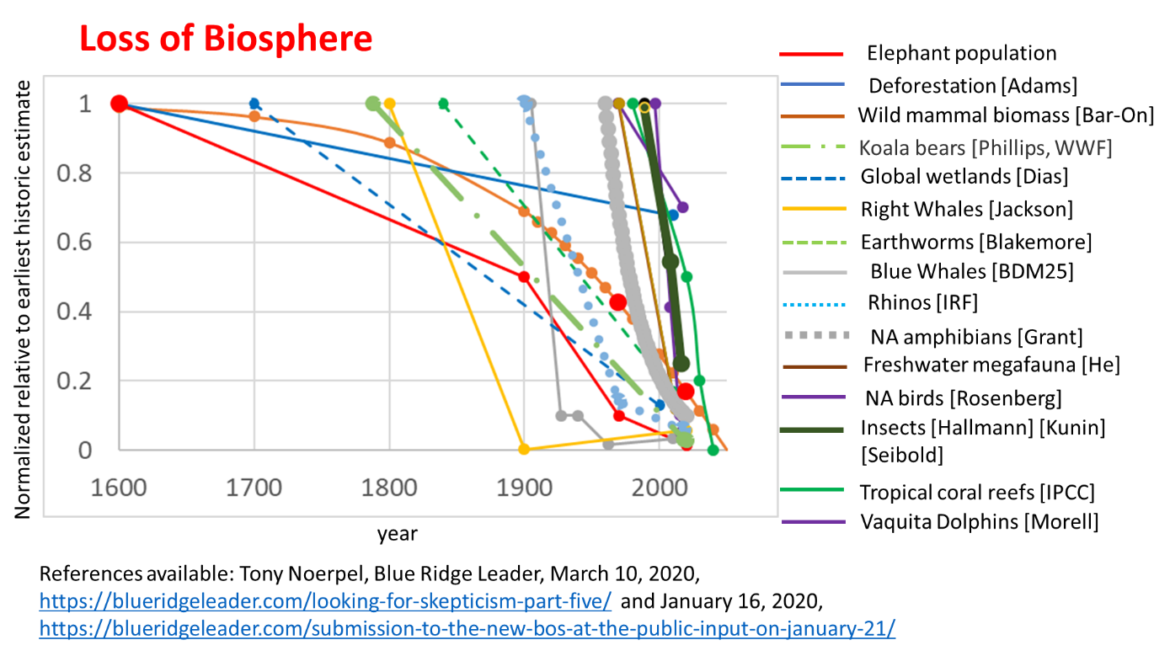
Figure 1. The collapse of the Earth’s biosphere and the initiation of the sixth major extinction event.

[Bell] Bell JS. On the Einstein-Podolsky-Rosen paradox. Physics (1964) 1:195, https://journals.aps.org/ppf/pdf/10.1103/PhysicsPhysiqueFizika.1.195

[Drawdown] https://www.drawdown.org/

Arnulf Grubler, A low energy demand scenario for meeting the 1.5 °C target and sustainable development goals without negative emission technologies, (2018) https://doi.org/10.1038/s41560-018-0172-6

[IPBES] Summary IPBES https://www.youtube.com/watch?v=I_lwdyctOEM

[NAS] National Academies of Sciences, Negative Emissions Technologies and Reliable Sequestration: A Research Agenda, http://nap.edu/25259

[Noerpel] https://blueridgeleader.com/tap-talks/

Pehl, M., Arvesen, A., Humpenöder, F. et al. Understanding future emissions from low-carbon power systems by integration of life-cycle assessment and integrated energy modelling. Nat Energy 2, 939–945 (2017). https://doi.org/10.1038/s41560-017-0032-9

[WWF] https://wwf.panda.org/knowledge_hub/all_publications/living_planet_report_2018/

